***Creating Our First Server with Express***

Steps:

1. Create new directory (mkdir my-express-server)
2. Go to this directory
3. Create new file server.js
4. Initialize it with npm (npm init)

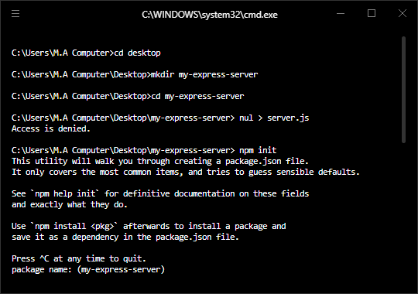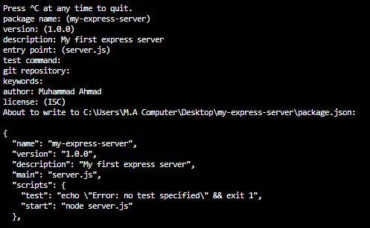

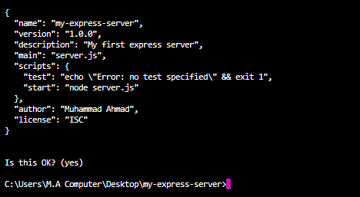

 // To open folder in atom (atom . or Atom .)

**Install Express:**

<https://expressjs.com/en/starter/installing.html>

npm install express –save //--save add express into package.json

npm install express

<https://expressjs.com/en/starter/hello-world.html> //Hello World example

**Stop the server:**

Press ctrl+c

Search **localhost:3000** //3000 is port size of localhost

Message will be

Cannot GET/

This means when server with 3000 port cannot get anything back.

const express = require('express');

const app = express();

//app.listen(3000); //Listen at port 3000 just a channel (server is tunned to a channel 3000)

//Add callback function

app.listen(3000, function(){

console.log("Server is running at Port 3000.");

});

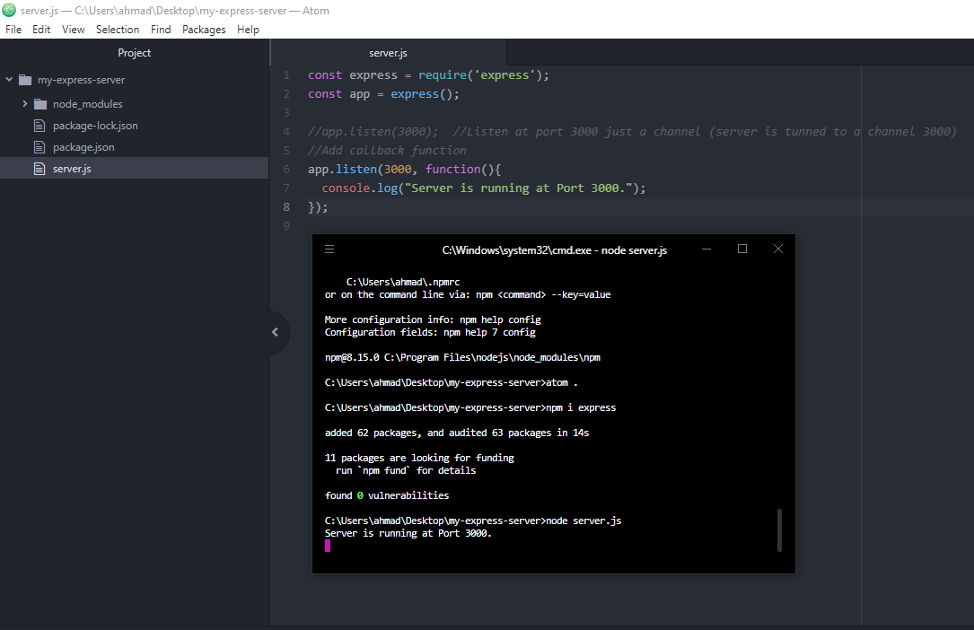

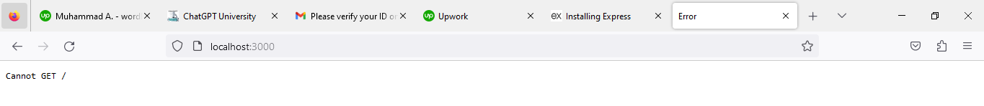

Now change the code to respond the request when server listen the browser request.